Asset List: Warehouse

1. **Industrial Lighting**
   1. Overhead
      1. Example: 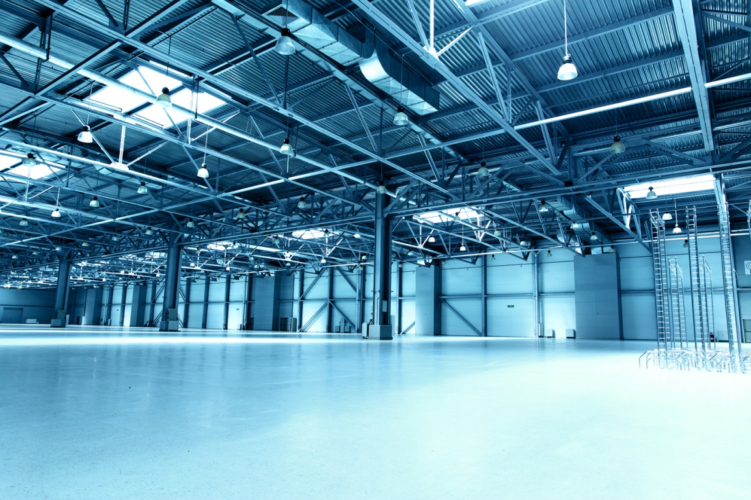
   2. Wall (The slender lights)
      1. Example: 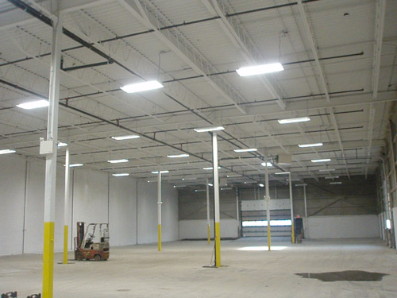
2. **Forklift**
   1. Example: 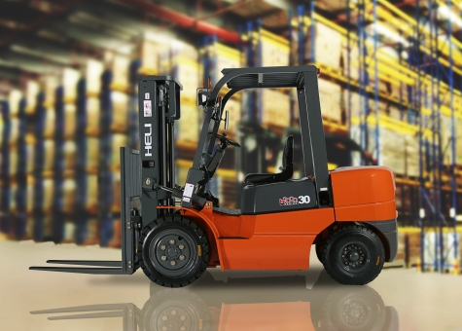
3. **Scaffolding (The bars that run across the top of the building)**
   1. Example: 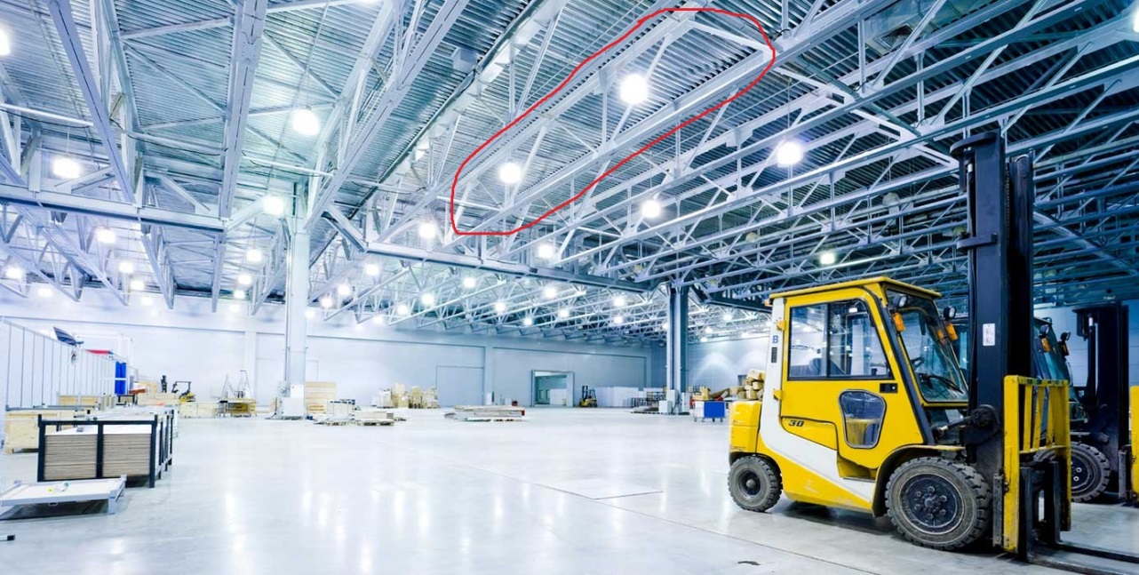
4. **Metal Shelving:**
   1. Example: 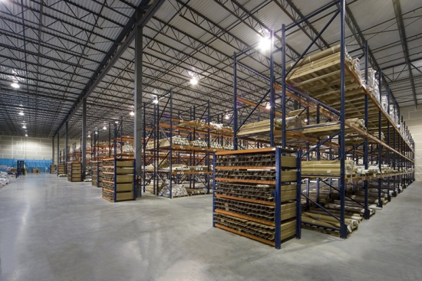
   2. Example: 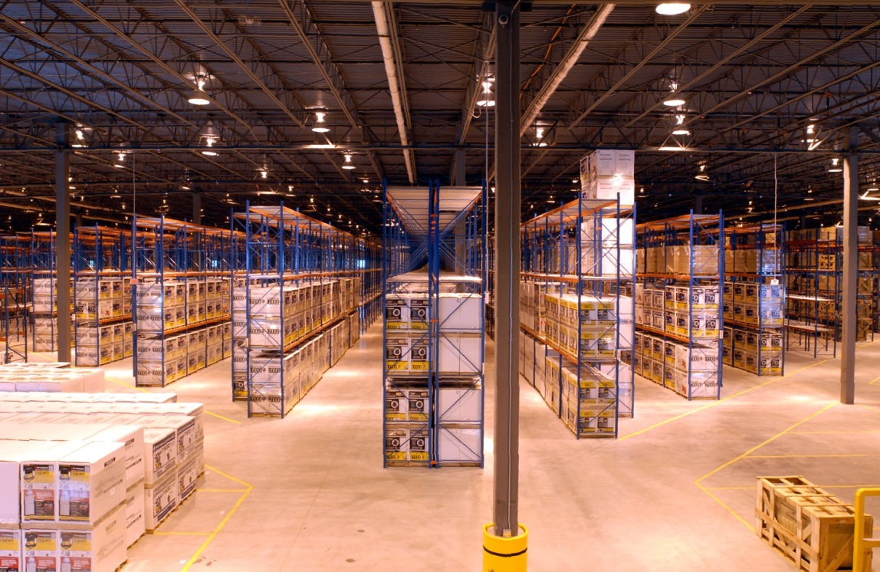
5. **Step Ladder**
   1. Example:

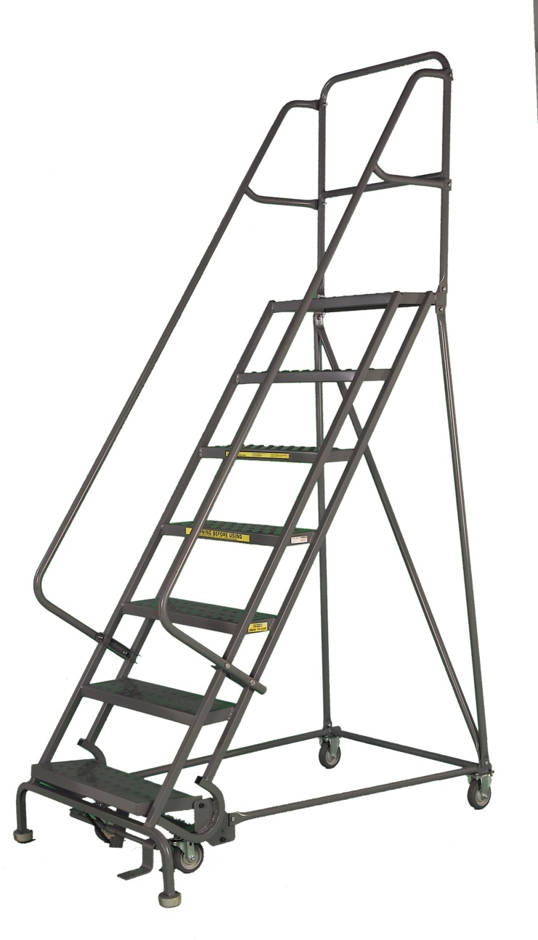

1. **Industrial Door**
   1. Example: (Front)

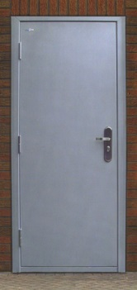

* 1. Example: (Back)

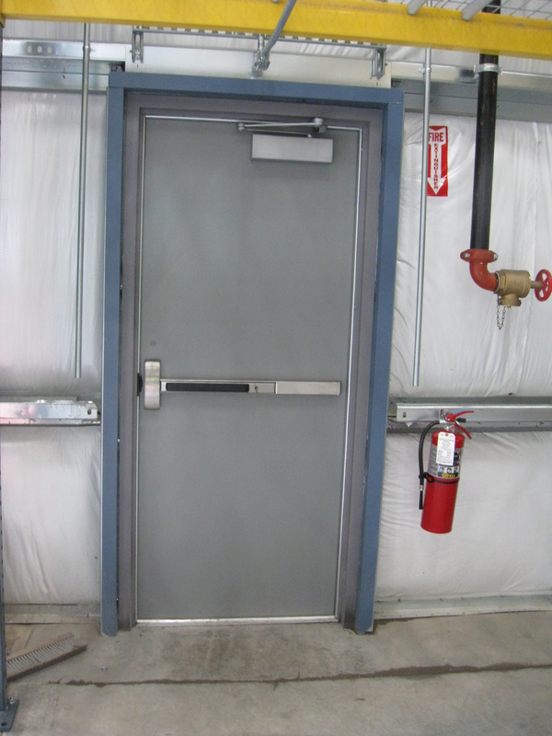

1. **Wooden Pallets**
   1. Example:

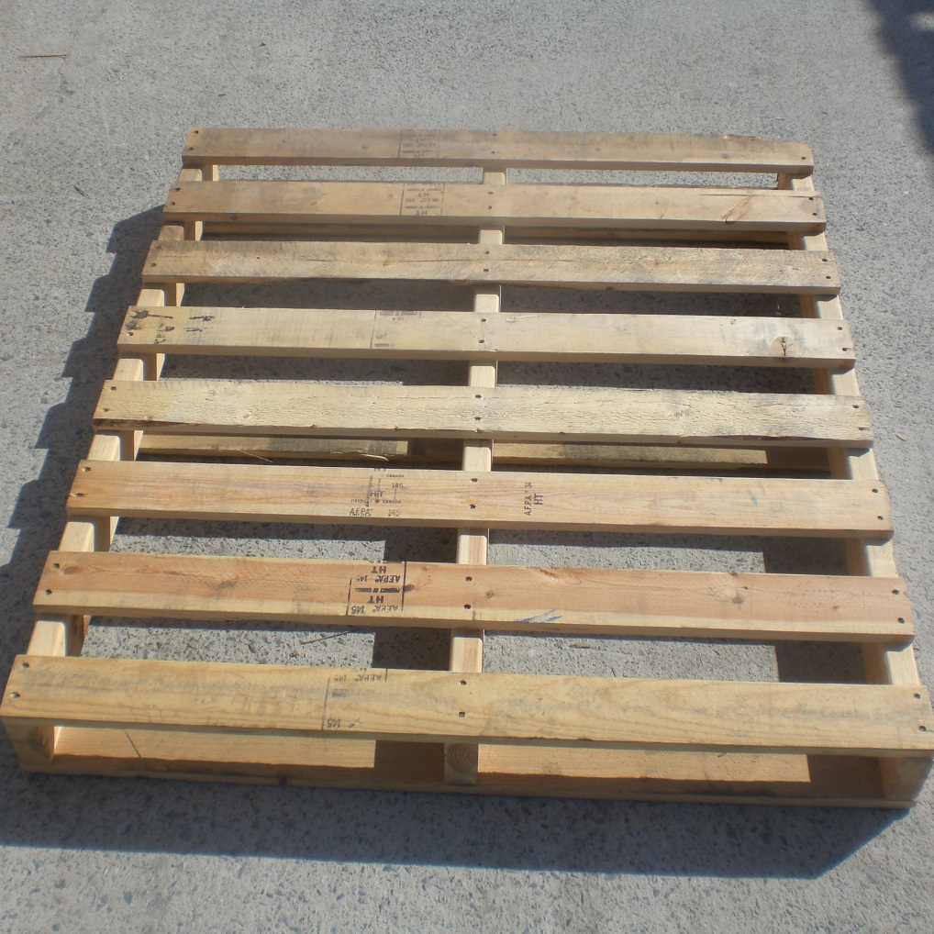

1. **Pallet Jack**
   1. Example:

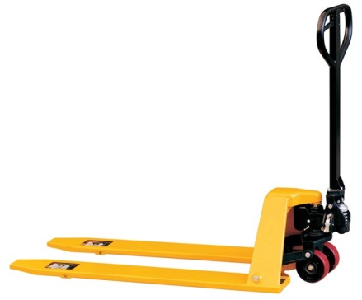

* 1. Example:

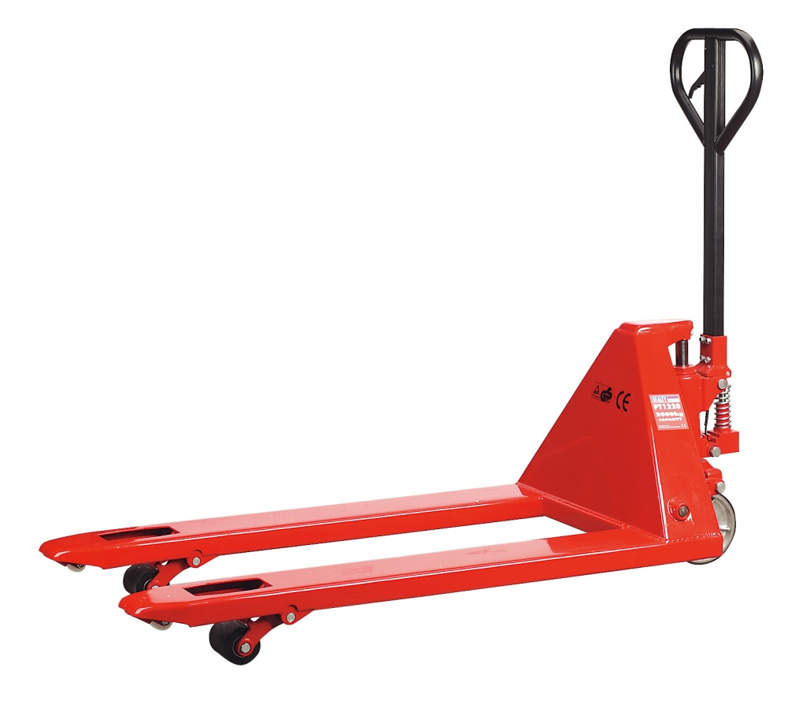

1. **Cardboard Boxes, of different sizes**
   1. Example:
      1. (Some plain boxes and some are wrapped in plastic/shrink wrap, some open)

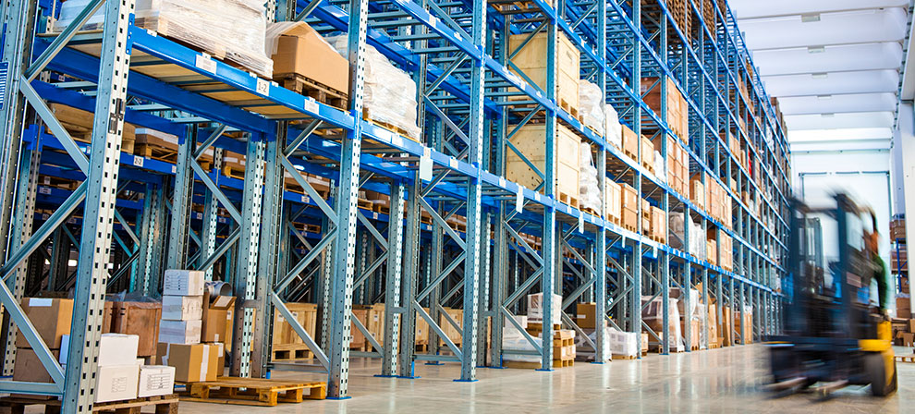

1. **30 Gallon Barrels**
   1. Example:

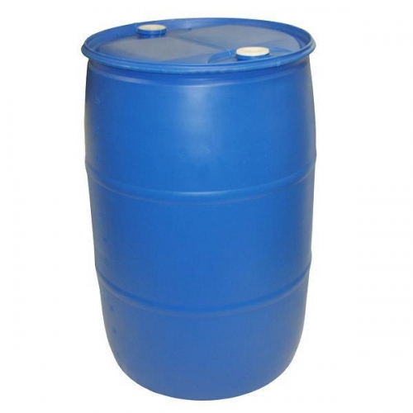

1. **30 Gallon Trash Can**
   1. Example:

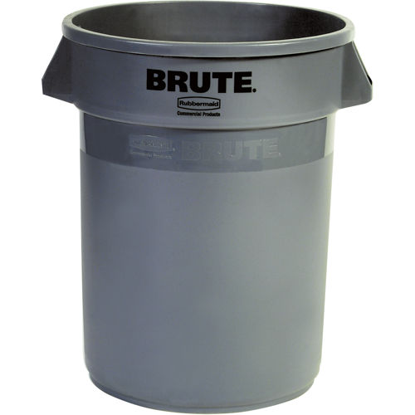

1. **Signs**
   1. Example

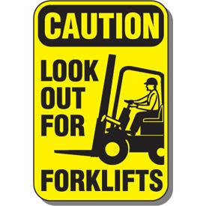

* 1. Example

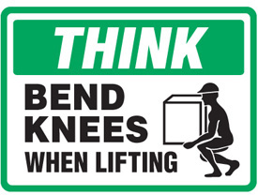

* 1. Example:

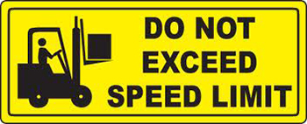

* 1. Example:

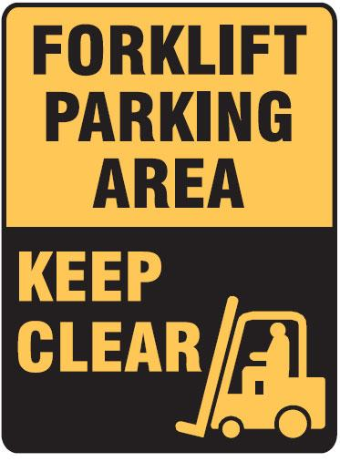

1. **Scissor Lift**
   1. Example:

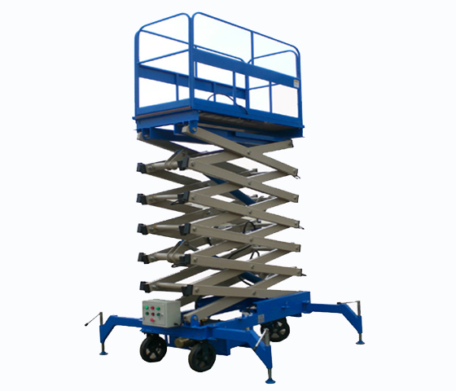

1. **Vents**
   1. Example

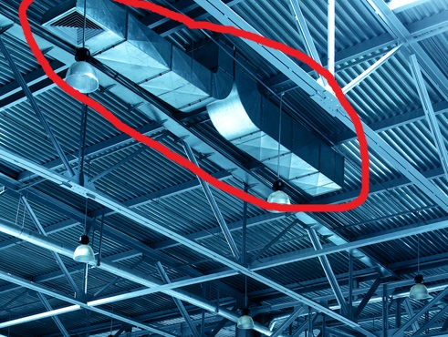

1. **Pipes**
   1. Example:

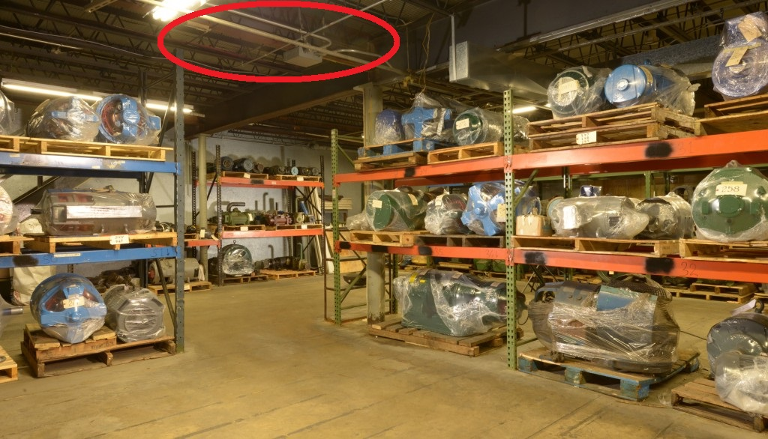

* 1. Example:

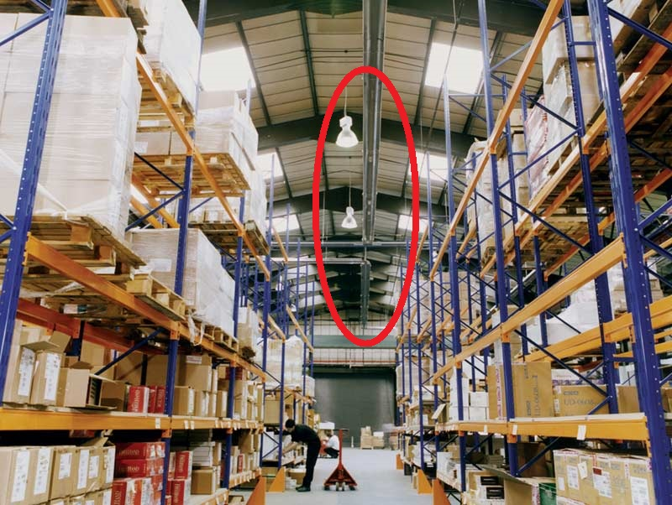

1. **Cable Reel**
   1. Example:

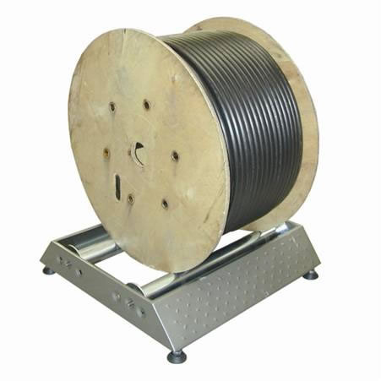

1. **Plastic Storage Crates**
   1. Example:

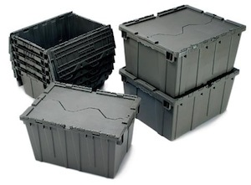

* 1. Example:

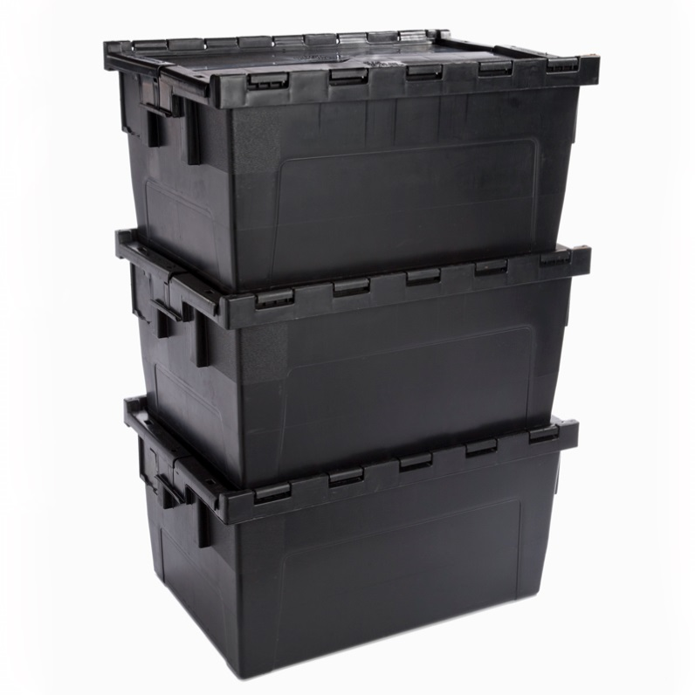

* 1. Example:

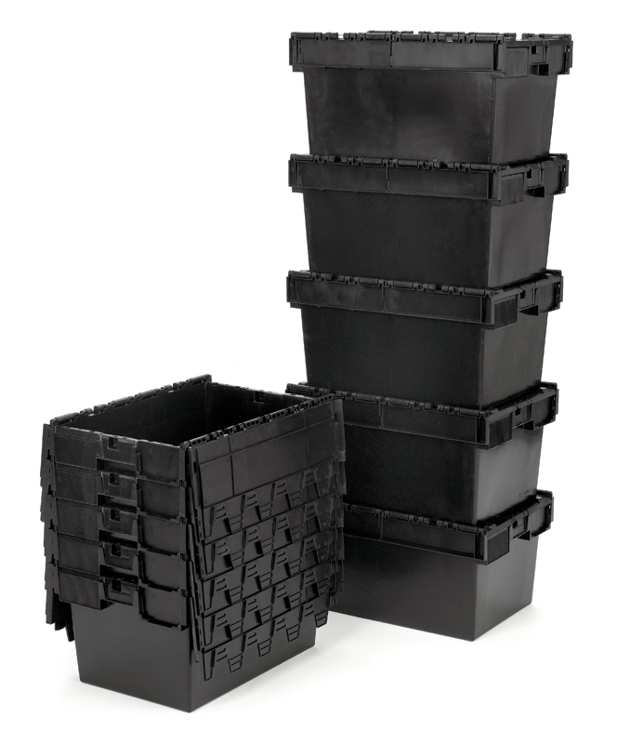

1. **Fire Extinguisher**
   1. Example:

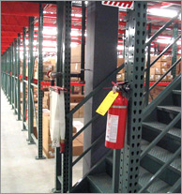

* 1. Example:

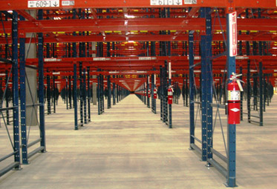

1. **10 Gallon Bucket**
   1. Example
      1. 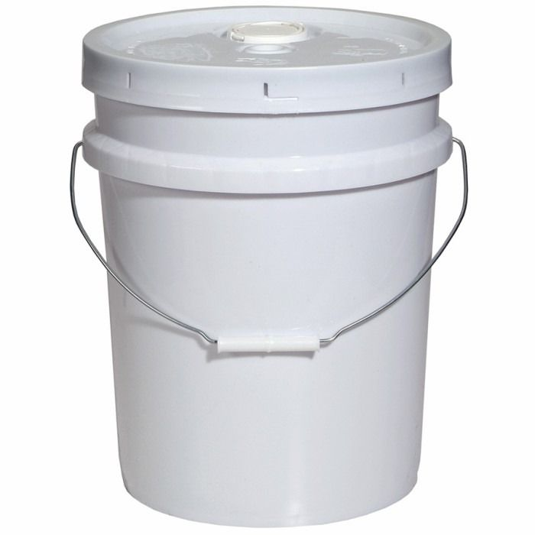
2. **Rolling Dolly**
   1. Example

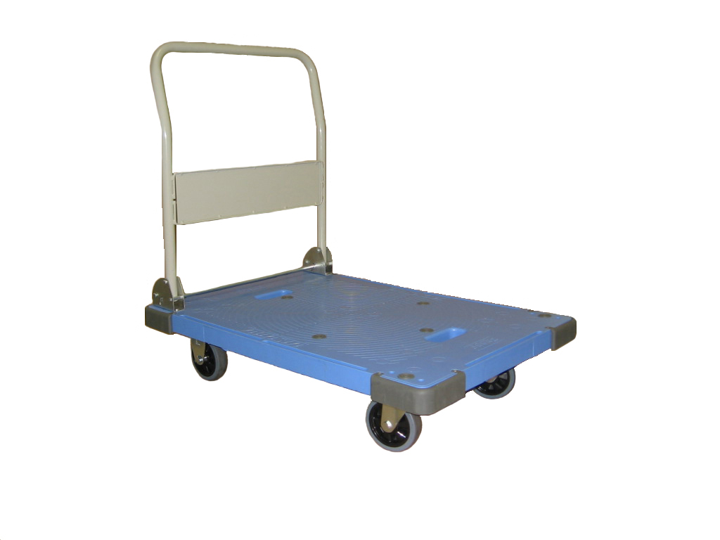

1. **Jugs**
   1. Example (Without the Label)

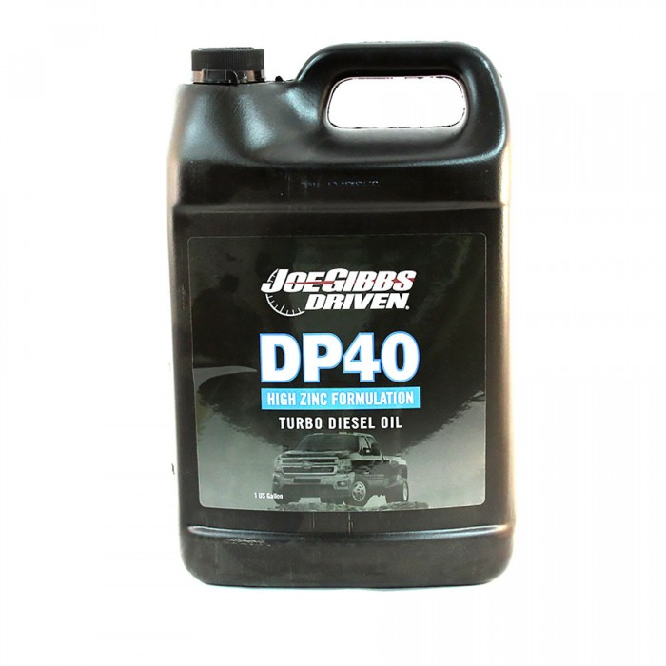

* 1. Example (Without the Label)



1. **Cones**
   1. Example



1. **100 Pound Bags**
   1. Example (One)



* 1. Example (Stack of Bags)

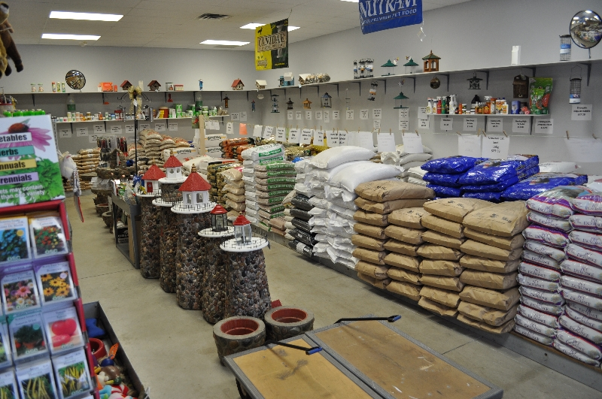

1. **Aisle Blocks**
   1. Example:

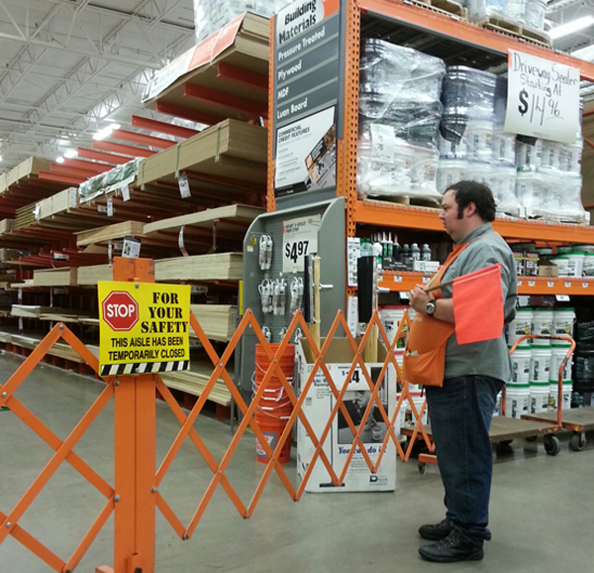

* 1. Example:

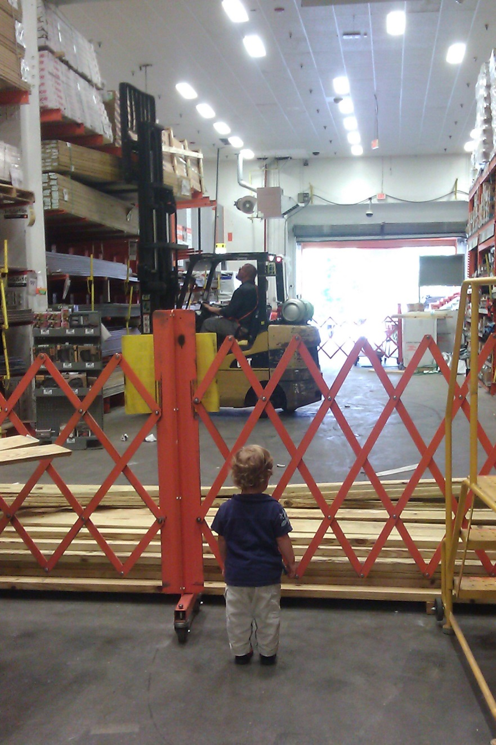

1. **Shelves**
   1. Example

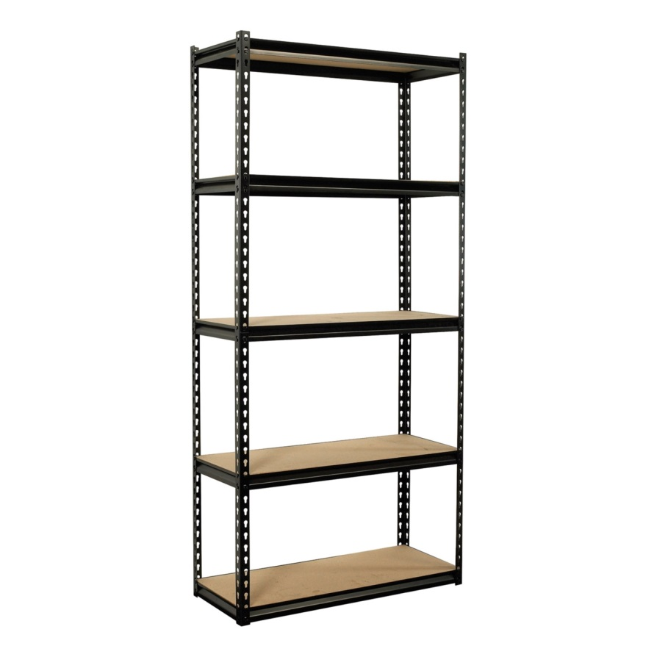

* 1. Example

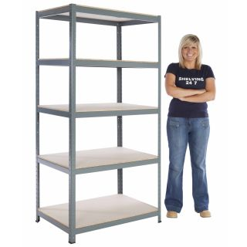

1. **Industrial Broom and Dust Pan**
   1. Example: Broom



* 1. Example: Dust Pan

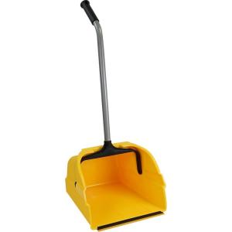

1. **Regular Broom and Dust Pan**
   1. Example

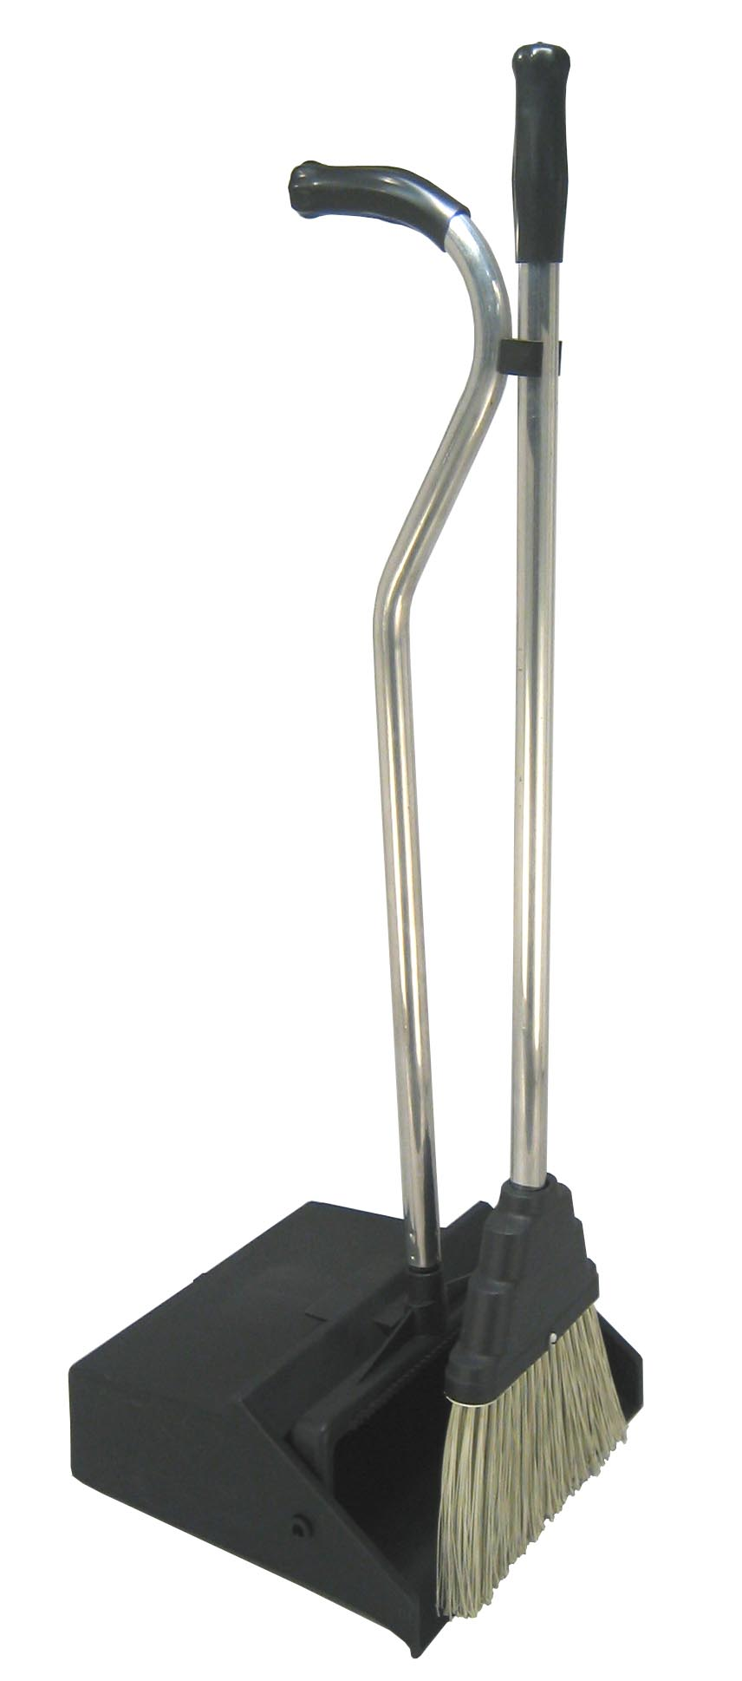

1. **Shirk Wrap Roller and Fillers**
   1. Example: Shrink Wrap Roller

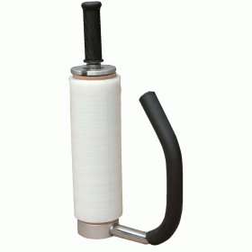

* 1. Example: Shrink Wrap Fillers

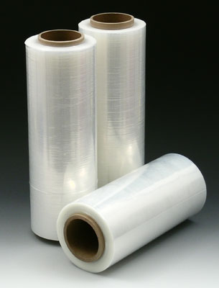

1. **Box Cutter**
   1. Example

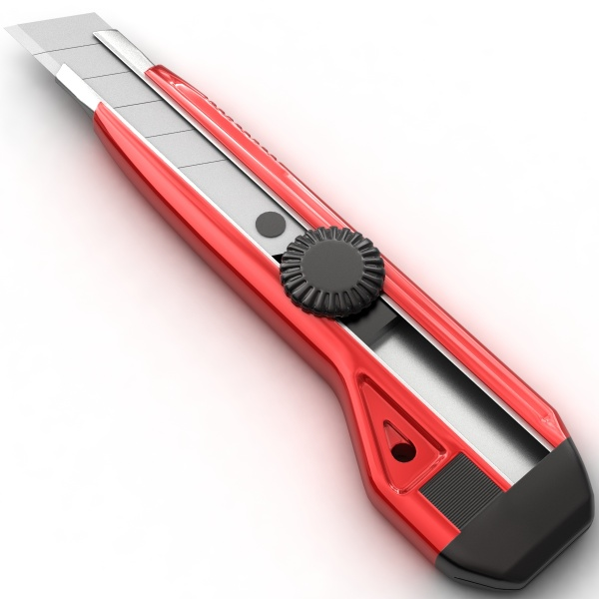

1. **Hard Hat**
   1. Example

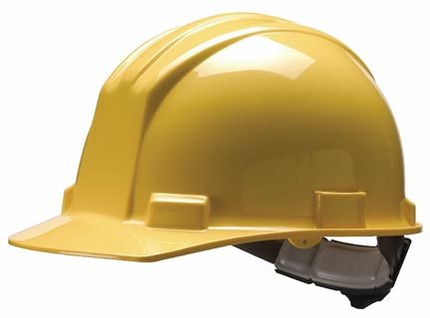

1. **Safety Vests and Pouch**
   1. Example
      1. Safety Vest

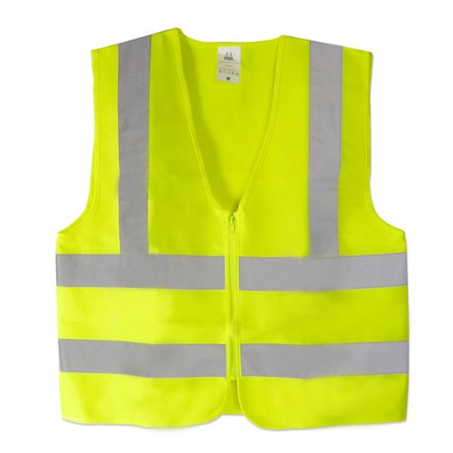

* 1. Example: Safety Vest Pouch

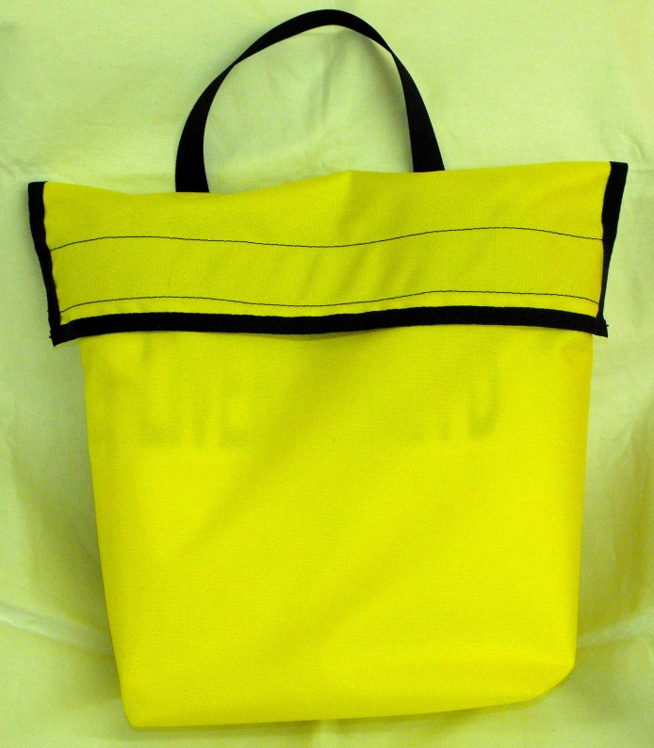

1. **Roll of Caution Tape**
   1. Example

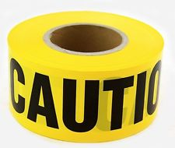

1. **Rolling Table**
   1. Example

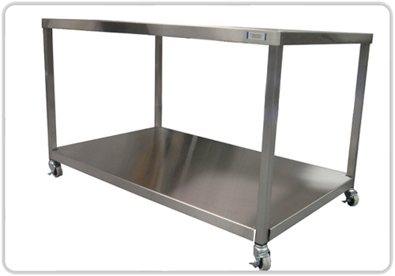

* 1. Example:

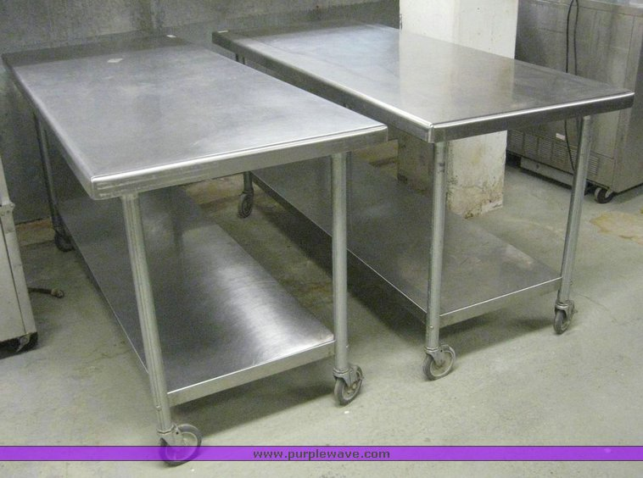

1. **Metal Storage Clip Board**
   1. Example
      1. **Preferably closed**

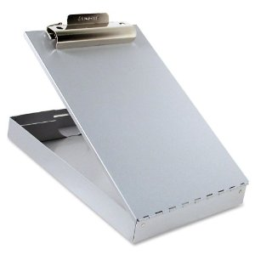

1. **Tilt Truck**
   1. Example

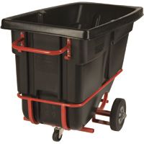

* 1. Example

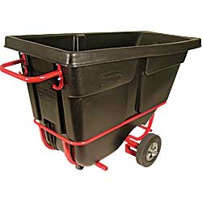

1. **Regular Trash Can**
   1. Example

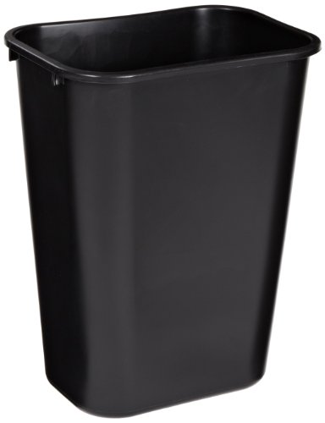

1. **Inventory Scanner**
   1. Example

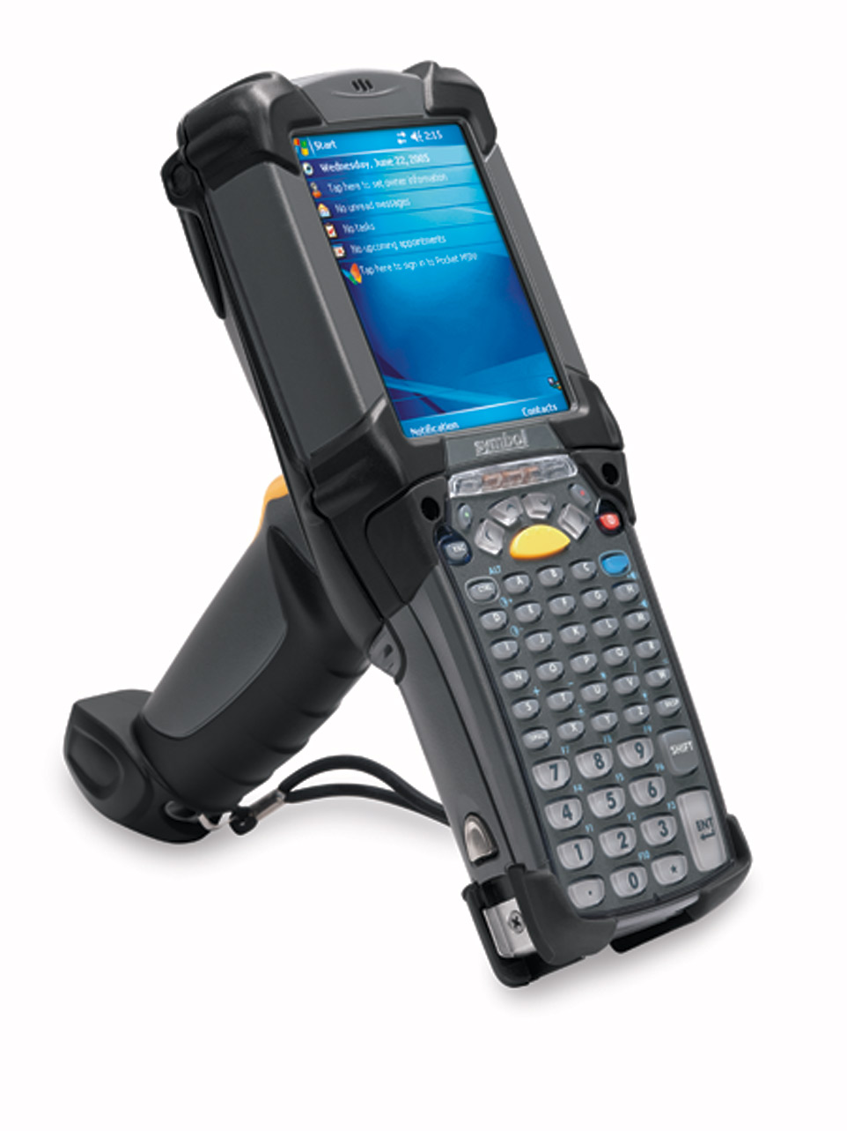

1. **Gloves**
   1. Example

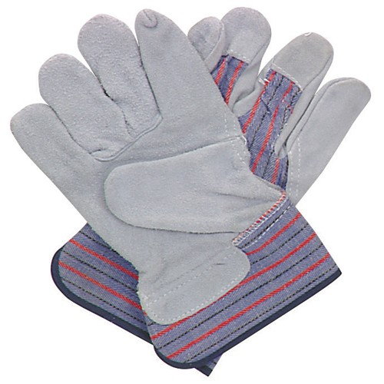

1. **Security Camera**
   1. Example

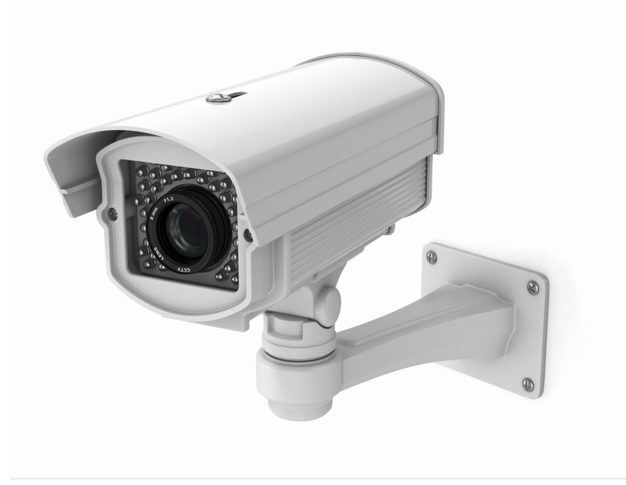

1. **Metal Storage Cabinet**
   1. Example

